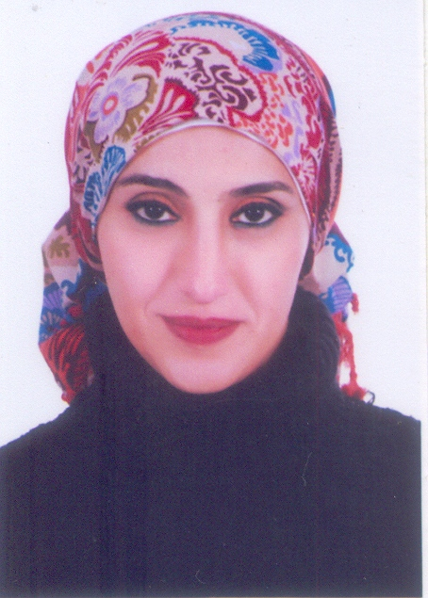
Curriculum vitae
1. Name: Fatma Alzahraa Elewa Elewa Rabai
2. Home Address: Compound 3 – El-Shereka El-Allamia Street, Maryoutea Road, Faysal Street, Giza, 5th Floor, Flat 501.
- Tel. home: 00202-37448327
- Tel. office: 00202-35675601
- Cell Phone: 0111500154
- E-mail: fatmaalzahraa75@yahoo.com

3. Personal information
- Place and date of birth: Egypt, Giza, 10-27-1975
- Present Nationality: Egyptian
- At birth: Egyptian
- Sex: Female
- Marital status: Married
4. Education
4.1. Higher education
- Name & address Institution: Cairo University, Faculty of Archaeology, Department of Egyptology.
- Main diploma: BA in Egyptology
- From/to: 1993 – 1997
- Grades obtained: Very Good with Honor

4.2. Post - graduate education
- M. A. Preparatory Studies: Cairo University, Faculty of Archaeology, Department of Egyptology, 1999.
- Master Degree: Cairo University, Faculty of Archaeology, Department of Egyptology, 2005.
- Title: Private Stone Statues from The Ptolemaic Period in Egypt Since the Conquest of Alexander the Great till The End of Cleopatra the Seventh Era (332 B.C. - 30 B.C.).
- Grades obtained: Excellent

- PhD: Cairo University, Faculty of Archeology, Greco Roman 2017, with title "Scenes of Hipis Temple from Dariaus the First Era and Comparison with Its Likeness in The Ptolemaic Temples in Egypt". at Cairo University, Faculty of Archaeology, Department of Egyptology
4.3. Additional training
- English Toefl test 2006, center for foreign languages and professional translation (CLT), Cairo University
- French language courses "Le Centre Français de culture et de cooperation de caire".
- Diplôme d' Έtudes en Langue Français (UITΈ A 1 – A4)
- Effective presentation skills
- Effective communication skills
- E-Learning
- Methods of scientific research
- Management of a research team
- Modern Methods in Teaching
6. Job description
- Teaching many courses as:
1. Ancient Architectural Landmarks
2. Ancient Egyptian Language
3. Archaeology of Middle Egypt in the Greek and Roman Periods
4. Museum Art and Paleontology
5. Archaeological Readings in a Modern European Language
6. Greek and Roman Antiquities in the Arab World
7. Archaeology of the Near East in the Greek and Roman Periods
8. Archaeology of the Mediterranean Islands
9. Greek and Roman Cities
10. Ancient Minor Arts
6. Professional experience:
- Present position: Assistant professor at Greek Roman Antiquities Department.
- Specialization: Late Antiquity, Greek and Roman Art and Architecture.
- Title: Department of Greek and Roman Antiquities, Faculty of Archaeology, Cairo university.
- Date started: 2018
- Brief description of major tasks and responsibilities:
    - 1998 till now: Guide for the faculty of archaeology students in the archaeological sites.
    - 2005 - 2007: Assistant in teaching ancient Egyptian archaeology for the third grade.
    - 2009-2010: Assistant in teaching Greaco-Roman history and archaeology for fourth grade.
    - 2010-2011: Assistant in teaching "Ancient Egyptian Society" for third grade.
    - 2012-2013: Assistant in teaching history and archaeology of the late period of ancient Egypt for fourth grade.
    - Membership in International associations:
      - Member at "The Arabian Archaeologist Society" from 1999 Till Now.
- Quality Coordinator for the Department of Greek and Roman Archaeology for the academic year 2022-2023.

